

Usman Institute of Technology

**Department of Computer Science Course Code: SE308**

**Course Title: Software Design and Architecture**

**Summer 2024**

**Lab 04**

**OBJECTIVE:** Working with the UML Activity Diagrams and State Transition Diagrams

## Student Information

|  |  |
| --- | --- |
| Student Name | **Jawwad Bhatti** |
| Student ID | **20B-011-SE** |
| Date | **21-07-2024** |

**Assessment**

|  |  |
| --- | --- |
| Marks Obtained |  |
| Remarks |  |
| Signature |  |

**Modeling with Activity Diagram**

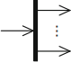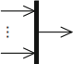

The following elements are available in an activity diagram.

1. Activity node

Activities can be broken down further

1. Initial node

Start of the execution of an activity

1. Activity ﬁnal node

End of ALL execution paths of an activity

1. Flow ﬁnal node

End of ONE execution path of an activity

1. Decision node

Splitting of one execution path into two or more alternative execution paths

1. Merge node

Merging of two or more alternative execution paths into one execution path

1. Parallelization node

Splitting of one execution path into two or more concurrent execution paths

1. Synchronization node

Merging of two or more concurrent execution paths into one execution path

1. Edge

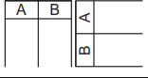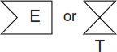

Connection between the nodes of an activity

1. Partition

Grouping of nodes and edges within an activity

1. Send signal action

Transmission of a signal to a receiver

1. Asynchronous accept (time) event action Wait for an event E or a time event T

Students Task

1. Draw activity diagram of online railway reservation

The two actors would be a customer and a ticket counter having following activities.

* + Search train
  + Check availability of train (if yes go to book ticket, if no go to quit)
  + Quit
  + Book ticket
  + Fill details
  + Submit details
  + Make payment
  + Print Ticket
  + Cancel ticket
  + Get refund

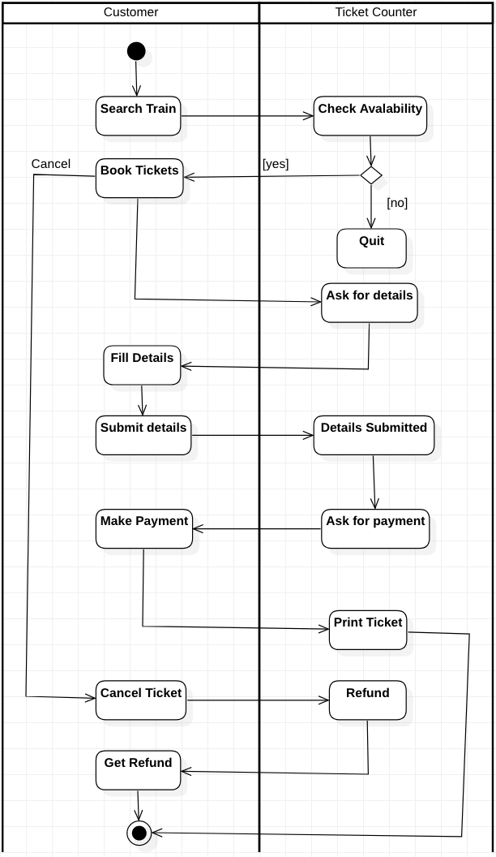

1. Draw activity diagram of patient management system having two actors Receptionist and Doctor. (e.g. Appointment Management System)

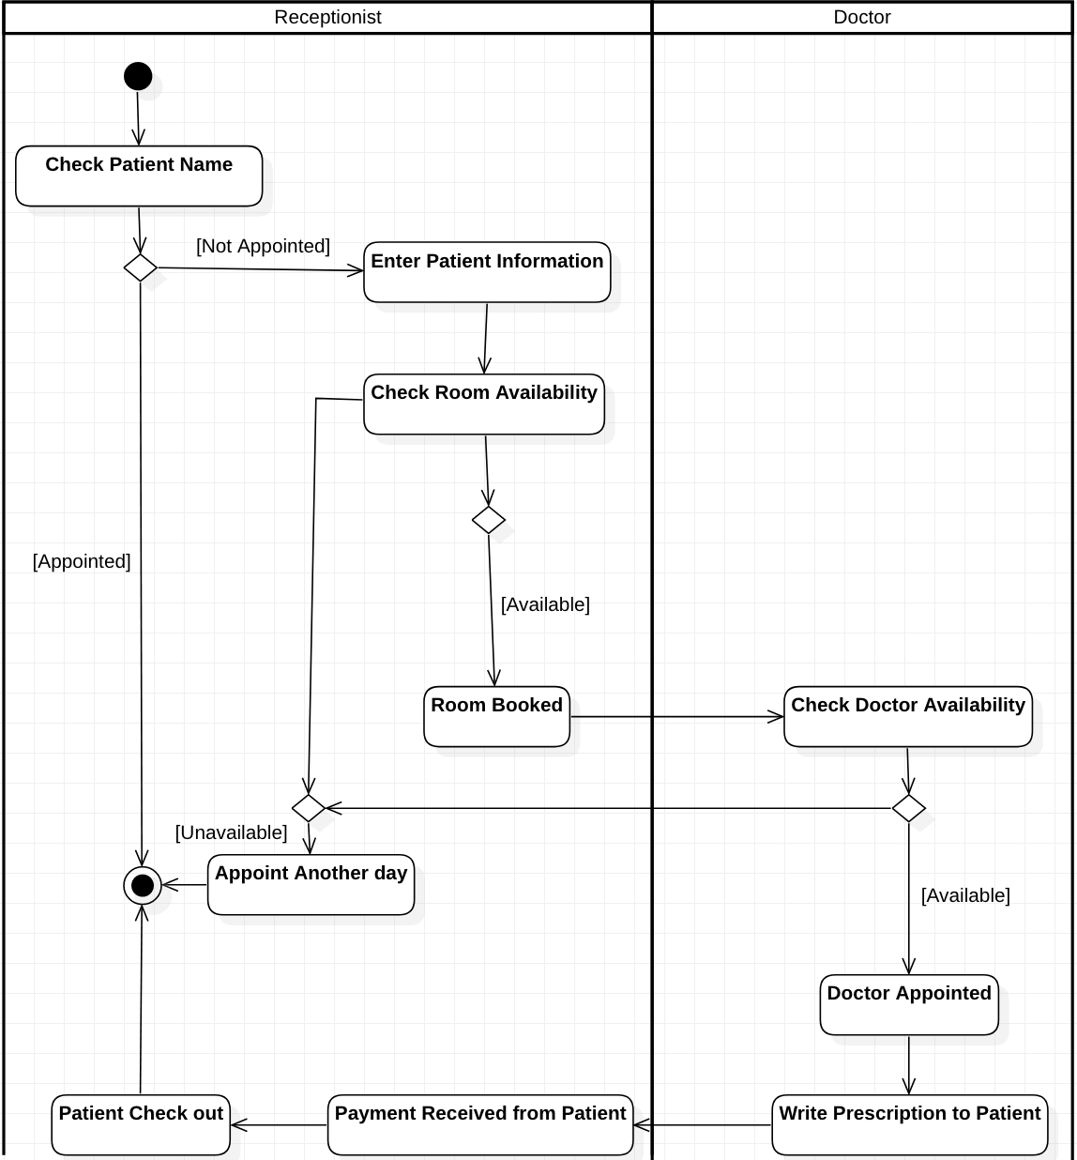

**State Transition Diagrams**

1. State

Description of a speciﬁc “time span” in which an object ﬁnds itself during its “life cycle”. Within a state, activities can be executed on the object.

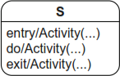

2. Transition

State transition e from a source state S to a target state T



3. Initial state

Start of a state machine diagram



4. Final state

End of a state machine diagram



5. Terminate node

Termination of an object’s state machine diagram

6. Decision node

Node from which multiple alternative transitions can proceed



7. Parallelization node

Splitting of a transition into multiple parallel transitions

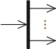

8. Synchronization node

Merging of multiple parallel transitions into one transition

# Students Task

1. Consider the bank account system where a bank account in either is Active or Dormant (inactive). If it is active, it could be either with zero balance or with some funds.

Create State Machine Diagram of the above banking system, mention all events and possible guards.Also include appropriate Entry, Do and Exit activities.

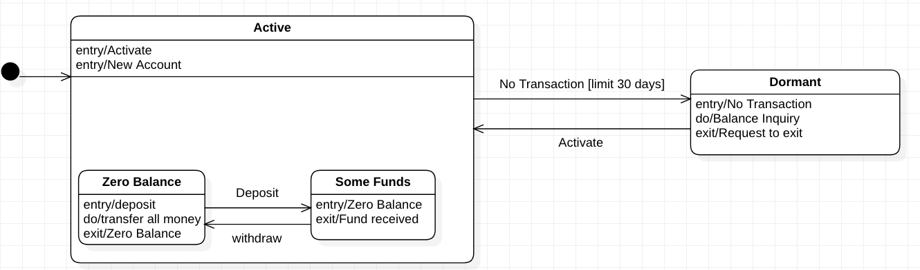

1. Consider the Scenario of Payroll Application
   * The manager first login and the system check the required credential provide by the manager.
   * It authenticates and if it is successful, it moves to the next state where the manager can add employee.
   * If the authenticate fails, it moves to a state where it again ask to reenter the credentials.
   * The manager can add employee and move to record deletion state or the report generation state or payment calculation state.
   * For payment calculation, the manger gives the requirements and system calculates the payments.
   * The report generation state generate report for manager which is followed by updating state where all the records of an employee is updated
   * The payment calculation state goes to error recovery state in case of error. after deletion of record state or updating of record state, the system ends the operation.

States detail are as below.

**Idle**: when no operation is performing in the system.

**Admin Login**: The manager logs and the system

**Retry login**: if login fail, this state gives chance to retry login again

**Adding employee**: this state add employee and their detail.

**Adding new record**: creates new employee. **Deleting record**: Delete records of employee **Report Generation**: Generate reports

**Payment calculation**: Calculate payment of employee

**Error Recovery**: If error occurs, this state helps to recover that state

**Update Record**: Updates records of an employee.

Create State Machine Diagram of the above Payroll Application, mention all events and possible guards. Also include appropriate Entry, Do and Exit activities.

